TEST - ANALYTICAL 10 qns 1 hour
---------------------------------
1.A frog in a well 30 ft deep jumps 3 ft slips 2 ft each day.How many days does take on the whole?
2.A man travels from A to B .He sleeps when there is yet twice the distance than already travelled to be covered.He wakes up half way thro' the journey .He again sleeps when there is still half the distance than already travelled left to be covered.he wakes up after reaching B.For what time of the journey did he sleep?

3.The letters below stand for numbers 0,1,2,3,4,5,6.Decipher them
DADCB
-EBEG
-------
BFEG

4.100 kgs of potato contains 99% water.Its kept in the sun.The water evaporates and now amount of water is 98 %.Whats the weight of the potatoes?

5.
2 men are walking towards each other at constant speeds.A train starting at one end crosses the first man in 18 seconds. After 10 minutes it meets the other man and crosses him in 12 seconds.(i am not sure of the values).Find the time when the 2 men meet after the train has crossed the second man .

6.
(not from the paper but worth a try)
The Angoras,the Bobcats and the Cougars are hockey teams.In 3 games the Angoras played against the Bobcats,the Bobcats played against the Cougars and the Angoras played against the Cougars.
a)The 3 final scores of the games consisted of the numbers 1,2,3,4,5,6.
b)The difference between Angora’s higher score and Bobcats higher score was one more than the difference between the Bobcats lower score and the Cougar’s lower score.
c)The highest total of a team’s two scores was achieved by the team that lost the greatest number of games.
Which team achieved the highest total of its two scores?

7
(not from the paper but worth a try)
N O S I E R
+ A S T R A L
----------------
7 2 5 6 1 3
In the addition above the sum represents a word.
a)Each letter represents a different digit.
b)No letter represents zero.
What word is represented by 725613 ?

8.
(again not from the paper but….)
Four women Anna ,Beth,Cass and Dora and three men Earl,Fred and Gene play bridge,a card game for 4 players.
a)The men and the women consist of 3 married couples and a widow.
b)The members of each married couple are never partners in a bridge game.
c)No more than 1 married couple ever plays in the same bridge game.
d)One night they played 4 bridge games in which the partners were as follows:

partners partners
Anna & Earl vs Beth & Fred
Anna & Gene vs Dora & Fred
Beth & Cass vs Fred & Gene
Cass & Earl vs Dora & Gene

Who is the widow ?

9.
On a certain island,5% of the inhabitants are one-legged.The total population is 10,000.If half of the two legged persons go barefoot,what is the least number of shoes needed in the island?

10
An egg vendor calls on his customer and sells half his eggs and half an egg.To the second customer he sells half of what is left and half an egg.To the third , he sells half of what he had left and half an egg.In the end he had 3 eggs remaining with him.How many eggs did he start out with?
(P.S:He did not have to break any egg!)

11.
0,1,2,3,4,5,6,7,8,9
Using the above digits exactly once fill in the question marks.
???
+ ???
-----------
????
----------

12.
A man decided to walk down an escalator while it was in motion.If he walks at his normal pace ,he would reach the bottom in 30 seconds and would step down 26 steps.If he walks faster , he would stepdown 34 steps and needs only 18 seconds .When the staircase is in standstill ,how many steps would he take?

13
In a family ,each boy has as many sisters as brothers but each girl has twice as many brothers as sisters .How many brothers and sisters are there?

Interview Puzzles
1.
'A' has a set of lock and its key.'B' has a set of lock and its key.A needs to send a letter to B in a Box .How do they do it if they dont part with their keys?
(Soln: 'A' puts the letter in the box sends it to 'B'.'B' locks it again and returns it to 'A'.'A' then unlocks his lock and sends the box to 'B' and 'B' uses his key to retrieve the letter.

2. A 12*12 feet carpet is to be used for a 16*9 feet floor with just 1 cut.how?
(Soln: Divide the carpet in the form of steps as shown)
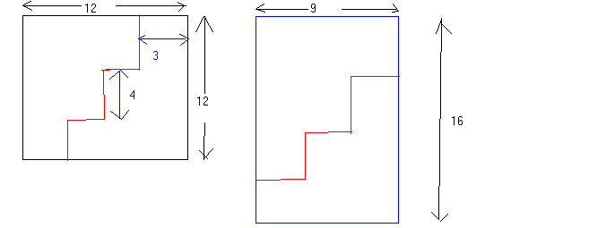

3.
3 boxes are labelled 2B,2R,1R 1B.They contain 2 blue,2 red and 1 red and i blue ball.all 3 boxes are labelled wrongly.With just one pick from any 1 box label the 3 boxes correctly.
(clue: pick 1 ball from the one labelled 1R 1B .If it is Red.............that shold be enough)
4
There is a pond of irregular shape and size .Suggest a method to find the volume of water in the pond.

5.
There are 3 bulbs in a room and 3 swithches outside the room .How do you find out switch and its corresponding bulb on the condition that you are allowed to enter the room only once.

6.
Construct 4 congruent triangles using only 6 matchsticks.
(soln:Construct a tetrahedron)
7.
A little ball was dropped from a height of 8 metres.It bounces back each time to a height which is one-half of the height of the last bounce.How far will the ball approximately travel before coming to rest?
(Soln: 24 metres)

Answers
--------------
1 28 days
2. Half the journey
3.
4. 50 kg
5.
6. The Cougars
7. INLETS
8. Cass is the widow
9. 10,000)
10 31 eggs)
11
12 46 steps
13 sisters –3,brothers-4

